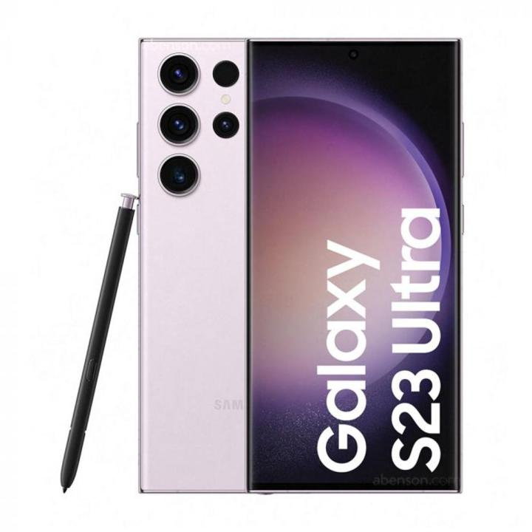
Galaxy S23 Ultra
The Samsung Galaxy S23 is a high-end, compact Android flagship smartphone from 2023, known for its powerful performance with the Snapdragon 8 Gen 2 for Galaxy chipset, excellent camera system, and all-day battery life.

Key Specifications
Feature | Details
Display | 6.1-inch Dynamic AMOLED 2X display with a 120Hz adaptive refresh rate and 1750 nits peak brightness
Processor | Custom Qualcomm Snapdragon 8 Gen 2 for Galaxy.
RAM | 8 GB.
Storage | 128GB or 256GB on-board storage options (128GB uses UFS 3.1, 256GB and higher use faster UFS 4.0).
Rear Cameras | Triple-lens setup: 50 MP main, 12 MP ultrawide, and 10 MP telephoto with 3x optical zoom.
Front Camera | 12 MP selfie camera.
Battery | 3,900 mAh capacity with 25W wired fast charging and 15W wireless charging support.
Operating System | Launched with Android 13/One UI 5.1, upgradable for four generations of Android OS and five years of security updates.
Durability | IP68 water and dust resistance and Corning Gorilla Glass Victus 2 on the front and back.
Reviews and User Experience

- Performance: Reviewers consistently praise the S23 for its fluid and fast performance, thanks to the custom Snapdragon chip, with apps opening quickly and no lagging during heavy use like gaming.
- Design: The phone has a premium feel and a compact, one-handed friendly design, which many users appreciate in an era of larger phones. The streamlined design with individual camera lenses, consistent across the S23 series, is considered sleek and attractive.
- Camera Quality: The camera system produces crisp, clear photos and stunning video, with 8K recording capability. The 3x optical zoom is a notable feature that reviewers find useful.
- Battery Life: A major improvement over its predecessor, the S23's battery life is described as "surprisingly good" and capable of lasting all day even with heavy usage.
- Software: The One UI software is considered one of the best Android interfaces available, offering extensive customization and useful features like Quick Share and Dual Messenger.

